
Company
Logotype

Cone Beam Computed Tomography- Report



Porur Dental X-rays & CBCT

Patient Name : Mrs. Renugadevi | Date of Report : 15.06.2025
Age/ Gender : 35 years/ Female | Region of Interest : CBCT Maxilla
Referring doctor: Dr. Selva Ganesh | Indication : 21, 22 region
Clinical Notes: Nil
PATIENT INFORMATION

CBCT- Sectional Maxilla provided
CBCT – IMAGE DETAILS

RADIOGRAPHIC INTERPRETATION

- Root stumps: 14, 16, 18, 26, 28.
- The tooth 23 appears to be positioned obliquely along the lateral border of the nose and the medial wall of the maxillary sinus, with its crown positioned anteriorly and the root positioned posteriorly.
- In relation to the periapical aspect of 21, 22, presence of diffuse unilocular area of hypodensity measuring 17.03 x 20.15 x 18.75 mm in dimension, is evident. The hypodensity appears to cause extreme thinning of labial bone, obliteration of the palatal cortical bone and alos appears to involve the lateral border of the maxillary sinus and the lateral border of the nose. The hypodense region appears to extend upto the midline.
- The alveolar ridge in relation to 23, 24, 25, 26, 27 is present with normal trabecular pattern.
- Mucosal thickening evident in the floor and wall of the left maxillary sinus.

RADIOGRAPHIC IMPRESSION

- Root stumps: 14, 16, 18, 26, 28.
- Periapical pathology: 21, 22
- Impacted tooth: 23.
- Left maxillary sinusitis.

Kindly correlate with clinical findings


IMAGES FOR REFERENCE

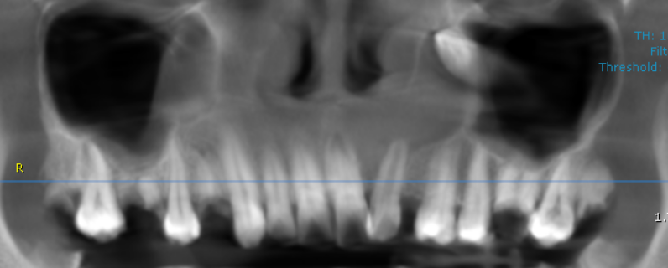
RECONSTRUCTED PANORAMIC VIEW

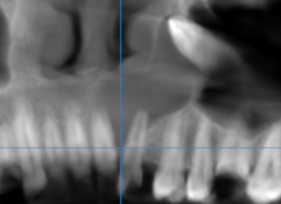

3-DIMENSIONAL VIEW

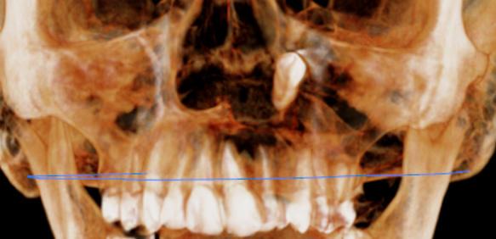

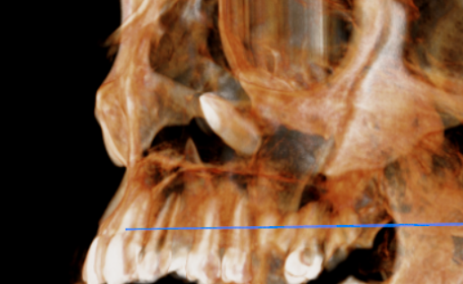

CROSS SECTIONAL VIEW
22 region

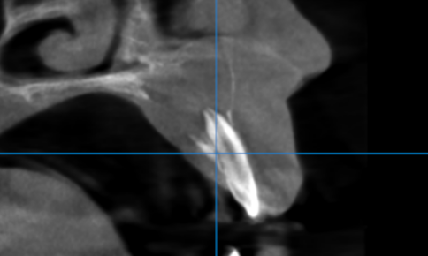

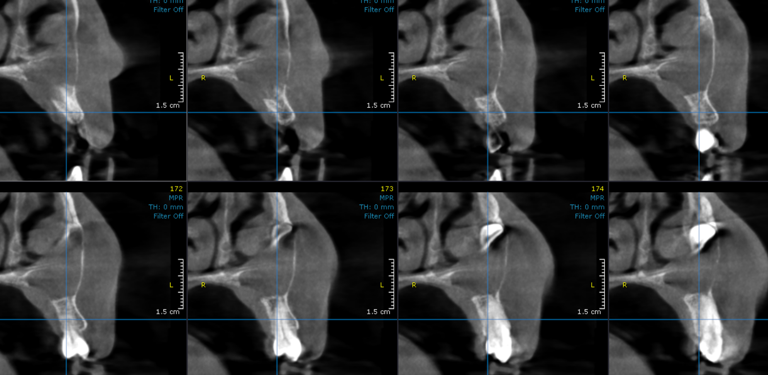

23 region

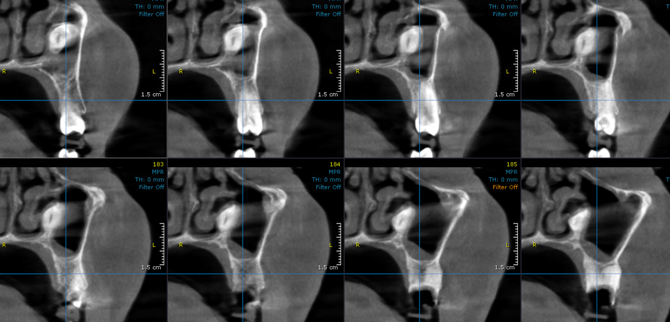
**** End of report ****

